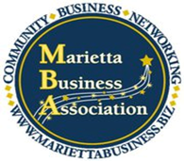

December 6, 2012

Eddie Williams
5690 Fairwood Drive
Acworth, GA 30101

Dear Mr. Williams,

It is has now been three weeks since you presented a seminar to the Marietta Business Association about Emotional Intelligence, and the members are still talking about how much they enjoyed that opportunity. To say that you were engaging is an understatement. I am sure each participant felt as though you were speaking directly to them personally.

The diversity in presentation materials and approaches made sure that all learning types and personalities were not only addressed but encouraged. With a group as diverse as ours it was both necessary and sincerely appreciated. You skillfully incorporated video, academic articles, pictures, anecdotes, personal assessments, numerous references and group discussion. The topic was fascinating and your knowledge of the content allowed you to address each person’s questions and concerns with ease. I am sure that every attendee left the meeting with something that they will be able to apply to both their personal and professional lives.

On behalf of the board and the membership of the Marietta Business Association, and I want to thank you again for providing such an incredible opportunity for us to have fun while exploring such pertinent information.

Sincerely,

Candice Medellin
President 2013
Marietta Business Association

